Your Assurance of Pure Silk | BANGALORE CHAPTER  SILK MARK ORGANISATION OF INDIA  [Sponsored by Central Silk Board, Ministry of Textiles, Govt., of India]  # 14, Vatal Nagraj Road, Oklipuram, Bangalore-21.  Regd., No. 1054/2003-04 Ph: 080-2342 1144
No: SMOI/BLR/EXPO/6A/2015-16 /Bangalore Date: 30-10-15

To

Sir/Madam,
Sub: Supply of Non woven hot Sealing Fabric Bags-regarding.
***************
I may refer to the subject cited above, I am to request to send rate quotations for supply of 10,000 Nos of Non woven hot Sealing Fabric Bags as detailed below:

- Name of the item : Non Woven Hot Sealing Fabric Bags
- Rate per bag :Rs. /bag
- Quantity in Nos. : 10,000 Nos
- Size of the bag : 14” x 18” x 3” with 5” Gusset ( side and Bottom)
- Handle model : WITH Handle
- Colour : Light Brown ( as per sample)
- Quality : 70 GSM Hot sealing Non Woven Fabric bag with Handle
- Design :Front - Silk Mark Logo and Silk Mark International Silk Expo 2015
Back - Silk Mark Logo with Vanya Silk Logo
- Type of packing : Each Bundle should contain 50 Nos of Bags
- Last Date for Quotation : 16-11-2015.
- Delivery of Bags : At our office on or before 10-12-2015

You are requested to follow the instructions strictly as given in the terms and conditions enclosed here with and send your lowest competitive rate quotation for print and supply of above said carry bags and to reach this office on or before 16-11-15 at 3 p.m.

The quotations so received well within the stipulated time shall be opened at 4.00 PM on the same day in the presence of the quotationer or their representative at the above said Office

For any / all information regarding art work and printing quality to contact ‘The Silk Mark Sr Executive, Silk Mark Organisation of India, Central Silk Board, ‘Resham Bhavan, #14, Vatal Nagaraj Road, Okalipuram, Bangalore – 560 021 (Phone:23421144 / 23120274).

Yours faithfully

(P.M.Pandi)
Deputy Director (Insp.) /
Senior Executive.

Silk Mark Organisation of India.Bangalore Chapter
TERMS AND CONDITIONS:
RATES AND APPLICABLE TAXES:
The parties should clearly quote the rates and applicable rate of taxes in their quotation separately. Any other statutory levies such as excise duty, entry tax etc., are to be quoted separately and clearly by the parties, for evaluation purposes and to conclude rate contract.
ESCALATION CHARGES:
No escalation charges will be entertained during the currency of the contract, once the quotation is accepted
and contract is awarded.
VALIDITY:
The rates quoted should be valid for a period of 30 days from the date of opening the quotation.
E.M.D
The quotation should be accompanied with 2 % EMD of the total amount quoted drawn in
favour of “Silk Mark Organisation of India” by a demand draft/pay order payable at Bangalore. The quotation received without EMD will be summarily rejected. The EMD amount for each item is indicated in the rate enquiry letter enclosed.
LAST DATE FOR SUBMISSION OF QUOTATION:
The last date for submission of the sealed competitive quotation addressed to The Deputy Director(I) / Sr Executive,
Silk Mark Organisation of India, Bangalore Chapter, Central Silk Board, “Resham Bhavan’ #14, Vatal Nagaraj Road, Okalipuram, Bangalore-560 021 is 16-11-15 up to 3.00 P.M. The envelope containing the competitive quotation
should be sealed and submitted duly super scribing on the envelope as “QUOTATION FOR THE SUPPLY OF SILK
MARK INTERNATIONAL SILK EXPO 2014 Bangalore - PUBLICITY MATERIAL” at the above address
LATE QUOATATIONS:
The quotations received after the due date and time prescribed shall be summarily rejected.
OPENING THE QUOTATIONS
The quotations so received well within the stipulated time shall Be opened at 4.00 PM on the same day in the presence of the quotationer or their representative at the Office of The Silk Mark Sr Executive, Silk Mark Organisation of India, Bangalore Chapter, Central Silk Board, “Resham Bhavan’ #14, Vatal nagaraj Road, Okalipuram, Bangalore-560 021.
LIST OF GOVT AND OTHER INSTITUTIONS TO WHOM WERE SUPPLIED:
Quotationers have to give the list of Government and other institutions to whom they have already supplied the carry bags as listed, along with the complete profile of the organization and manufacturers name, their trade mark and brand of any should be invariably mentioned in the tender and illustrative leaflets giving technical particulars etc., are to be attached to the tender to facilitate consideration of the offer.
LIQUIDATED DAMAGES:
Failure to supply the quantity within the stipulated period, when ordered, the Silk Mark Organisation of India shall deduct from the quoted price, as liquidated damages, a sum equivalent to 0.5% of the quoted price for the delayed supplied for each week until actual delivery, upto a maximum deduction of 10% of the quoted/contract price. Once the maximum of 10% is reached the SMOI is at liberty to cancel the order.
REFUND OF E.M.D:
The EMD amount of the unsuccessful bidders shall be returned, by a cheque, within 30 days from the date of opening of the quotation. The EMD of the successful quotationer shall be discharge only after satisfactory supply of the materials ordered.
FORFEITURE OF THE E.M.D:
Failure to supply the ordered material within the stipulated period shall result in forfeiture of the E.M.D.
INCREASE OR DECREASE THE QUANTITY:
The Sr Executive/Deputy Director(I), Silk Mark Organisation of India, Central Silk Board, Bangalore Chapter, reserves the right to increase or decrease the quantity of the material.
RIGHT TO ACCEPT OR REJECT:
The Silk Mark Sr Executive, Silk Mark Organsiation of India,Central Silk Board, Bangalore Chapter reserves the right to accept or reject any [or] all the quotations either in part or in full without assigning any reason’s/thereof.
PAYMENT:
The bill of cost for supply of the ‘Silk Mark International Expo 2015 carry bags shall be made only after satisfactory supply of the materials ordered. No advance payment shall be made for the supply of these items.
ADDITIONAL INORMATION, IF ANY: For any/all information, the successful quotationer may contact The Silk Mark Sr Executive, Silk Mark Organisation of India, Central Silk Board, ‘Resham Bhavan, #14, Vatal Nagaraj Road, Okalipuram, Bangalore – 560 021 (Phone: 23421144 / 23120274).web:silkmarkindia.com/tenders

ANNEXURE

Front side

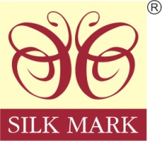
Your Assurance of Pure Silk

Buying silk?
Insist on Silk Mark Labelled Products

Silk Mark Expo Logo
Silk Mark International Silk Expo 2015
Bangalore
15th to 20th Dec 2015

Silk Mark Organisation of India, Bangalore
www.silkmarkindia.com, Ph-080-23421144/23120274

Back Side
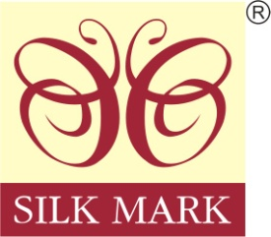
Your Assurance of Pure Silk

Buying silk?
Insist on silk mark labeled products

Eco friendly Indian Silk

Silk Mark Organisation of India, Bangalore
www.silkmarkindia.com, Ph-080-23421144/23120274

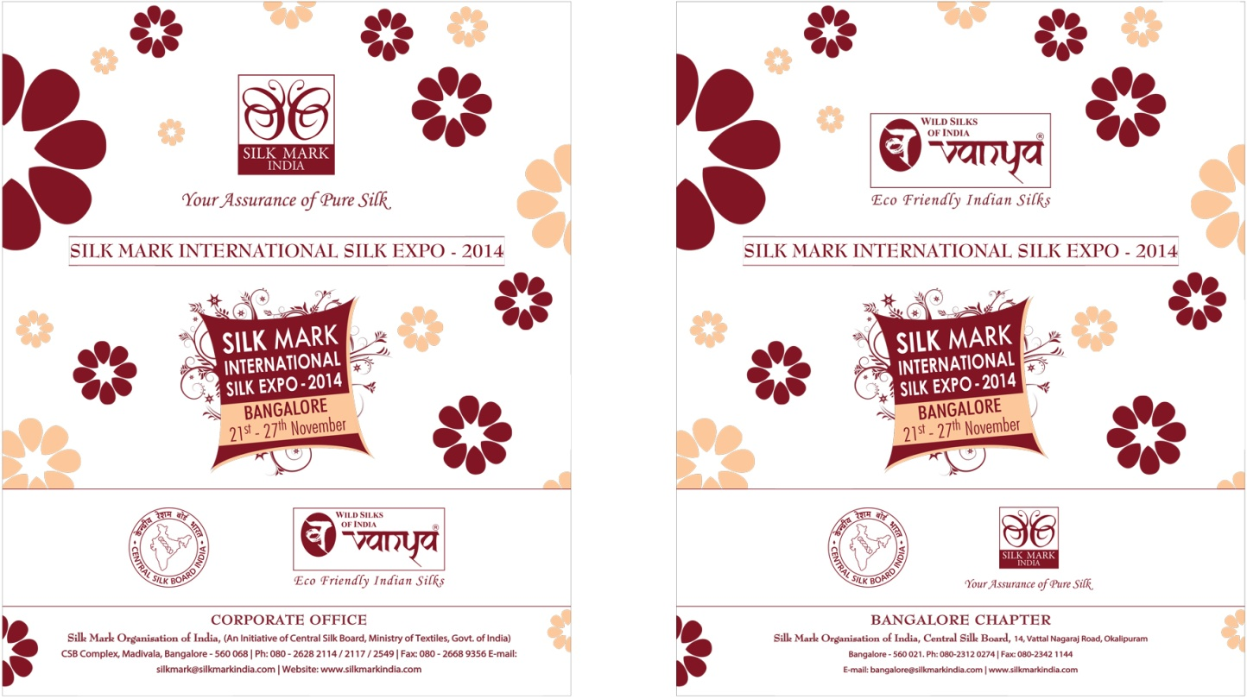

Front Back side
Back ground (Light Brown Colour)
Design and text in Maroon Red colour

